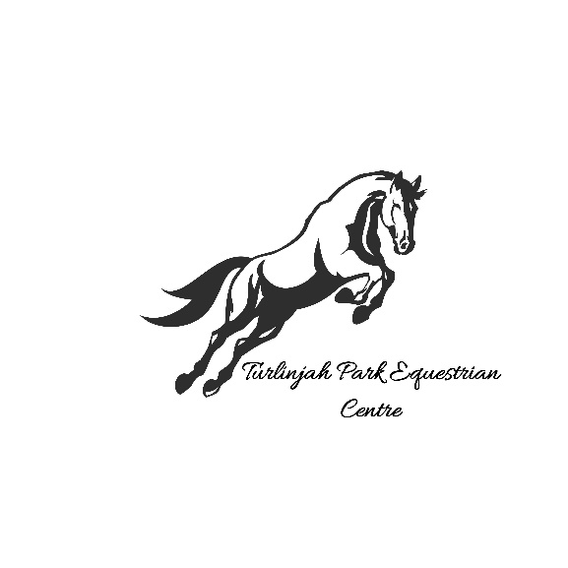

**Policies and procedure's**

* All riders must sign a waiver form before mounting a horse.
* All riders and visitors must follow the directions of the coach and staff or will be asked to leave.
* Please make sure you are aware of our evacuation points and procedures these can be found on the white board.
* All fees must be paid before the lesson unless prior arrangements have been made.
* Term invoices must be paid within 2 weeks of receipt. If not paid riders will not be able to ride until the invoice is paid.
* If lessons are cancelled by Turlinjah park due to weather or other events, make up lessons will be arranged, or credits given. No other make-ups or credits will be offered for missed lessons or change of mind.
* All gates must be always closed.
* Bullying or harassment of any type will not be tolerated, and you will be asked to leave.
* Riders, coaches, and staff only allowed in the horse area.
* Spectators, parents, and care givers please remain in the spectator area unless permission has been given by the coach to enter the horse area or arena.
* NO DOGS to be brought onto the premises.
* DO NOT enter premises if no staff member is present.
* Riders must be wearing helmets and correct footwear around horses.
* **No Smoking** inside the property.
* As per Equestrian Australia weight policy

The maximum load that a horse is expected to carry should not exceed 20% of the horse’s approximate weight. That is, the athlete and equipment should not weigh more than 20% of the horse’s approximate weight.